Team 4
Birasala Navya Chowdary LNU
1002254980
Lokesh Ram Hariram
1002241602
Anurag Lende
1002231584
Manali Bhosle
1002121840

Optimizing the Performance of Data Warehouse by Query Cache Mechanism
Authors: Saddam Hussain, Syed Sajid Ullah
Publication: IEEE Access, Volume 10, 2022

The paper delves into possible ways to improve data retrieval from Data Warehouses to cope with the ever-growing needs related to Business Intelligence. In the research, the authors introduce the use of a cache-based approach toward the optimization of data access through reduced execution time and proper cache space management through an aging-based Least Frequently Used algorithm.

Methodology and Innovations

This mechanism is based on a cache management strategy that uses the aging-based Least Frequently Used algorithm, which integrates data size and frequency of use with aging for determining the priority of cache content. The hybrid technique is different from traditional LFU, LRU, or even simple size-based algorithms in that it gives priority scores for:

- Frequency of Access: The higher the frequency of any data item being accessed, the higher priority it would get.

- Data Size: Smaller, or sometimes larger, blocks of data are considered to achieve economical utilization of memory.

- Aging Factor: Dynamically maintains a threshold to ensure that not-so-recently used items are eventually replaced to avoid cache pollution.

The pseudo-code provided by the authors shows in detail a process for the handling of queries in two different states: "valid" and "invalid." At the time of issuing a query, first of all, the state of the cache is checked. If the data is present and valid, it is directly retrieved, which reduces the execution time significantly. Otherwise, if not, the query goes to the main DW, after which the result is cached for possible future use.

Experimental Setup and Results

The authors have tested their mechanism using an Intel Core i5-8265U CPU with 1.6 GHz, 8 CPUs, 8 GB RAM, and SSD storage. The simulations included several data sizes to demonstrate the performance of the proposed cache mechanism against the traditional mechanisms of caching. Key findings from the experiments were:

It reduces execution time-especially on large requested data-because the aging-based LFU outperformed size-based and basic LFU techniques.

Cache Efficiency: Considering the size, frequency, and age of data, the proposed method minimized cache misses and kept high hit rates.

Resource Optimization: It requires no hardware accelerations like state-of-the-art processors or cloud-based solutions, hence cost-effective.

Comparative Analysis

It compares the proposed cache strategy with the following existing techniques:

- LRU: It efficiently removes the least recently accessed data, whereas it becomes inefficient in the case of data access frequency with small size.

- LFU: It prioritizes data that is used frequently, but sometimes leads to cache pollution if some old infrequently accessed data remains behind.

- Size-Based Policy: It offers a greedy approach towards space optimization by removing larger data blocks.

- The authors proposed a hybrid approach that combined these techniques into one and resulted in better performance metrics for query response time and cache utilization.

Practical Implications and Future Work

The research will be of special relevance to those businesses and organizations depending on a BI system for real-time data analysis and decision support. Through proper optimization of cache usage, the mechanism ensures faster access to data, hence fulfilling a user's experience and operational effectiveness. This paper identifies that such a cache mechanism may help bridge the gap between DW systems in respect of ad hoc user queries and allow quicker insights based on data.

The authors also extend this by proposing that, in the future, the implementation of the cache mechanism should be done in a real-world OLAP server environment for further validation of its performance. Further improvements, such as materialized views and query concatenation, are suggested in refining query response times with minimal redundant processing. This might set a new benchmark for efficient DW query optimization by integrating these methods.

Conclusion

The paper have given an attractive solution for overcoming data retrieval challenges in Data Warehouses using an advanced, software-level cache mechanism. Certainly, aging-based LFU, a frequency-, size-, and data-aging-aware algorithm, would serve as an efficient strategy that maintains optimal cache states. It promises to be very promising in the performance improvement of DW in the BI systems with no heavy investments in hardware, hence making it scalable and practical in today's data-driven environments.
Report on “Healthcare Data Security and Privacy in Data Warehouse Architectures”

Authors - Ranul D. Thantilage, Nhien-An Le-Khac, M-Tahar Kechadi

The article "Healthcare Data Security and Privacy in Data Warehouse Architectures," by Ranul D. Thantilage, Nhien-An Le-Khac, and M-Tahar Kechadi provides thorough research on the multifaceted issues within the domain of healthcare data management in data warehouse systems. Published in Informatics in Medicine Unlocked (2023), it discusses the twin priorities of protecting sensitive clinical information and meeting the requirements of privacy protection while presenting innovative architectural and technological solutions.

The authors begin by sharing the intrinsic challenges health care data management presents. This includes dataset complexities in the domain of clinical datasets, including structured, semi-structured, and unstructured formats, and an increasing need to access data in real-time. They point out that traditional data-management ways do not live up to expectations in these facets, and instead advocate for distributed data warehouse architectures to provide better scalability and, most importantly, strong privacy protection.

This paper discusses three different configurations of a data warehouse: centralized, distributed, and hybrid, with their relative merits and drawbacks. Thus, distributed architectures become the first choice for healthcare applications due to their scalability and ability to integrate data from a variety of sources. Advanced schema designs like galaxy and fact constellation schemas are recommended for a proper representation of relationships among the complex healthcare data.

The authors give security measures such as encryption, stringent control of access, and regular security auditing to deal with security vulnerabilities that include cyber-attacks, archaic systems, and breach of data. Concerning privacy, the risks are identity theft, reputational harm, and failure to adhere to regulations; strategies therefore presented are data anonymization, de-identification, and secure data views.

A few of the emerging technologies, such as blockchain and machine learning, are identified as major enablers in strengthening data security and privacy. Blockchain gives an immutable framework for secure data transactions, while machine learning enhances anomaly detection and automates security protocols.

This paper makes a substantial contribution to literature on healthcare data management, as it emphasizes the concept of privacy-by-design in data warehouse systems. It carries an in-depth analysis of current challenges and presents actionable solutions that will integrate the most modern technologies. Further, it delivers practical guidance on achieving compliance with the likes of GDPR and HIPAA.

The conclusion effectively advocates advanced architectural and technological approaches to address the biggest needs in healthcare data security and privacy today. In fact, it gives really insightful directions for all researchers and industry practitioners working on improving healthcare data warehousing and security by highlighting the potential of distributed systems and emerging technologies.

Academy Integrity Form

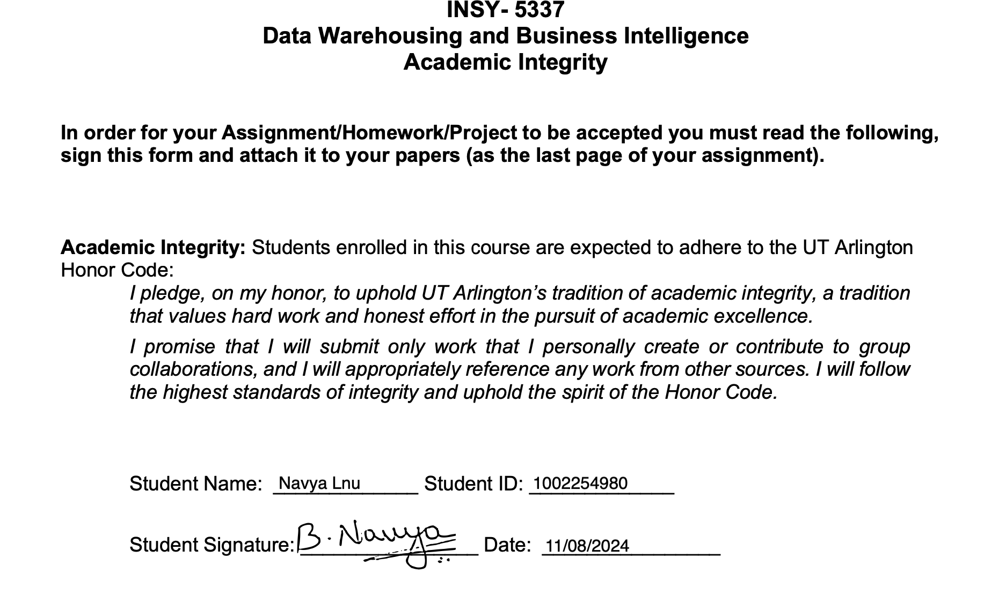

INSY 5337 : DATA WAREHOUSE AND BUS INTELL
Academic Integrity
In order for your Assignment/Homework/Project to be accepted you must read the following, sign this form and attach it to your papers (as the last page of your assignment).
Academic Integrity: Students enrolled in this course are expected to adhere to the UT Arlington
Honor Code:
I pledge, on my honor, to uphold UT Arlington’s tradition of academic integrity, a tradition
that values hard work and honest effort in the pursuit of academic excellence.
I promise that I will submit only work that I personally create or contribute to group
collaborations, and I will appropriately reference any work from other sources. I will follow
the highest standards of integrity and uphold the spirit of the Honor Code.
Student Signature: LOKESH RAM HARIRAM
Student Id Number: 1002241602
11/17/2024
